TUTORIAL 4 – FUNCTIONAL & NON-FUNCTIONAL TESTING
Project Name: Online User Management System
IDE/Tool Used: VS Code / Eclipse / IntelliJ
Testing Type: Functional & Non-Functional Testing
Test Techniques: Positive and Negative Testing
SDLC Model: Agile Model

FUNCTIONAL & NON-FUNCTIONAL TEST CASES

Scenario Id- 1a

Test Scenario: Login with Valid Credentials

Test Objective: To verify that a registered user can successfully login.

Test Steps:

1. Open Login Page.
2. Enter valid username.
3. Enter valid password.
4. Click Login.

Test Input: Username: admin
Password: admin123

Expected Result:

User should be logged in successfully and dashboard should be displayed. - PASS

Actual Result:

Test executed successfully and expected result achieved - PASS.
Status:

Pass

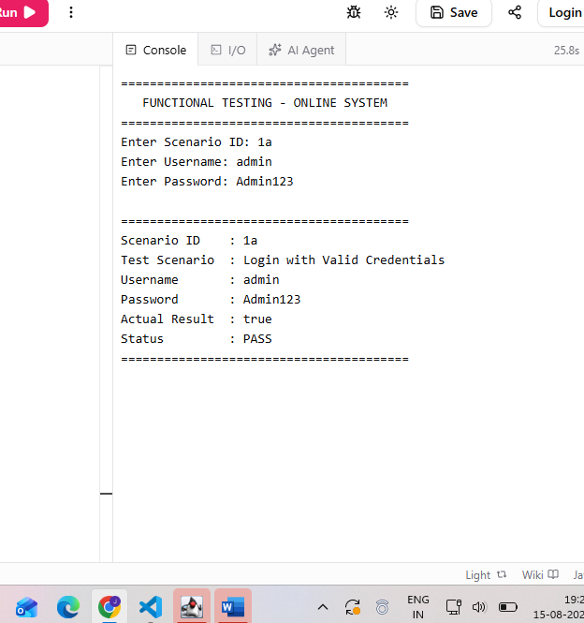

Scenario Id- 1b

Test Scenario: Login with Invalid Username

Test Objective: To verify that the system rejects an invalid username.

Test Steps:

1. Open Login Page.
2. Enter invalid username.
3. Enter correct password.
4. Click Login.

Test Input:

Username: wronguser
Password: admin123

Expected Result:

Login should fail and an appropriate error message should be displayed. - PASS

Actual Result:

Test executed successfully and expected result achieved - PASS.

Status:

Pass
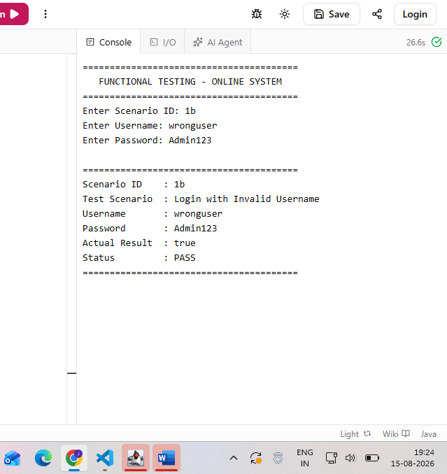

Scenario- 1c

Test Scenario: Login with Invalid Password

Test Objective: To verify that the system rejects an incorrect password.

Test Steps:
1. Open Login Page.
2. Enter valid username.
3. Enter incorrect password.
4. Click Login.

Test Input:

Username: admin
Password: wrong123

Expected Result:

Login should fail and an error message should be displayed. - PASS

Actual Result:

Test executed successfully and expected result achieved - PASS.

Status:

Pass
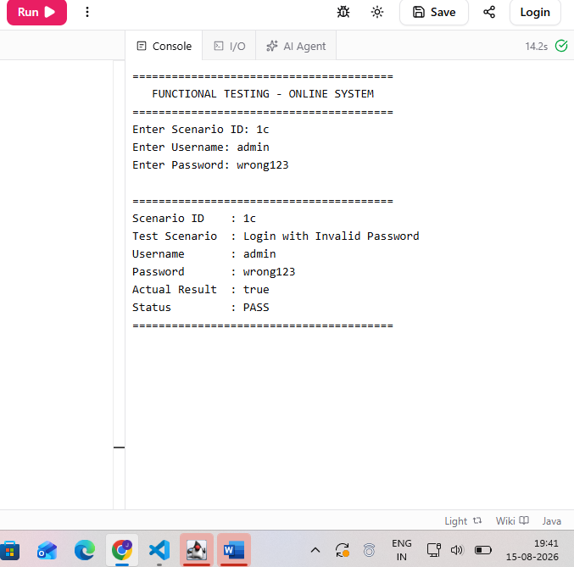

Scenario- 1d

Test Scenario: Login with Both Invalid Credentials

Test Objective: To verify that the system does not allow unauthorized login.

Test Steps:

1. Open Login Page.
2. Enter invalid username.
3. Enter invalid password.
4. Click Login.

Test Input:

Username: wronguser;
Password: wrong123

Expected Result:

Login should fail and an error message should be displayed. - PASS

Actual Result:

Test executed successfully and expected result achieved - PASS.

Status:

Pass
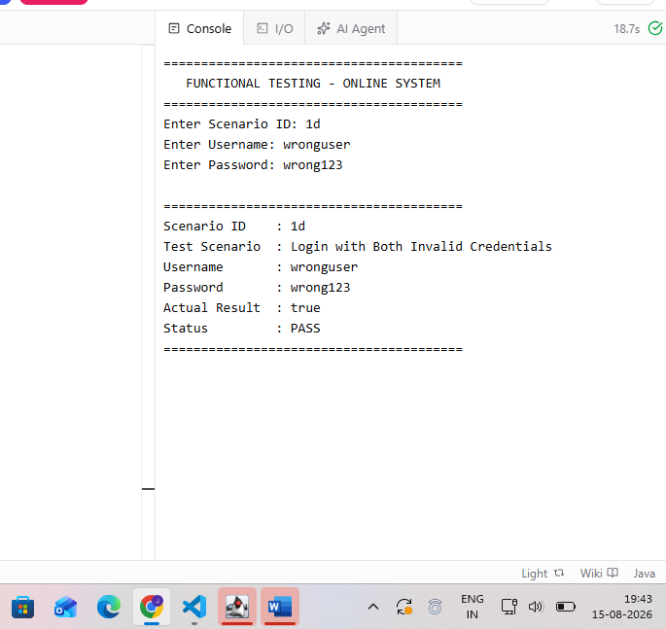

Scenario Id - 1e

Test Scenario: Login with Empty Username

Test Objective: To verify username required validation.

Test Steps:

1. Open Login Page.
2. Leave username blank.
3. Enter password.
4. Click Login.

Test Input:

Username: Blank;
Password: admin123

Expected Result:

Username required validation message should be displayed. - PASS

Actual Result:

Test executed successfully and expected result achieved - PASS.

Status:

Pass
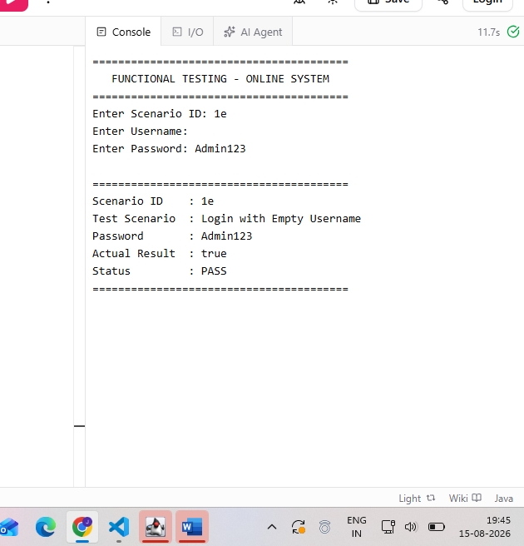

Scenario Id - 1f

Test Scenario: Login with Empty Password

Test Objective: To verify password required validation.

Test Steps:

1. Open Login Page.
2. Enter username.
3. Leave password blank.
4. Click Login.

Test Input:

Username: admin;
Password: Blank

Expected Result:

Password required validation message should be displayed. - PASS

Actual Result:

Test executed successfully and expected result achieved - PASS.

Status:

Pass
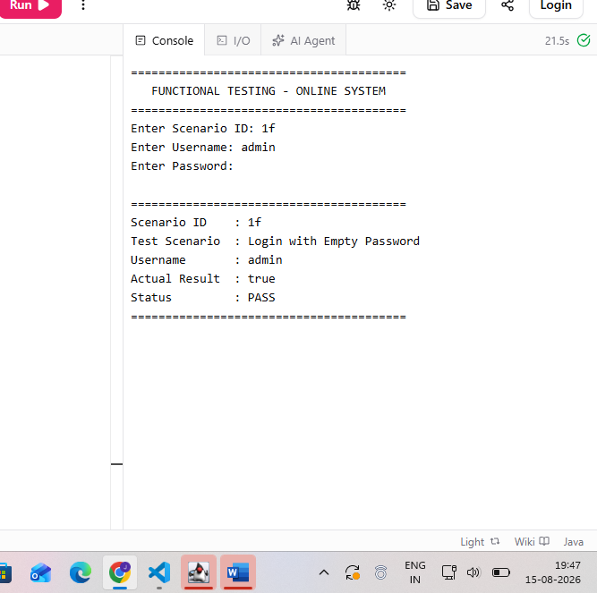

Scenario Id- 1f

Test Scenario: Login with Both Fields Empty

Test Objective: To verify mandatory field validation.

Test Steps:
1. Open Login Page.
2. Leave username blank.
3. Leave password blank.
4. Click Login.

Test Input:

Username: Blank;
Password: Blank

Expected Result:

Validation messages should be displayed for required fields. - PASS

Actual Result:

Test executed successfully and expected result achieved - PASS.

Status:

Pass

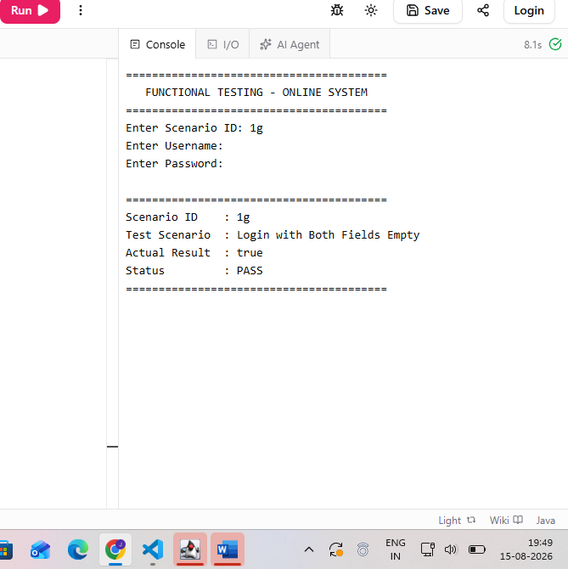

Scenario Id - 1h

Test Scenario: Login Page Usability

Test Objective: To verify that login controls are clearly visible and easy to use.

Test Steps:
1. Open Login Page.
2. Observe username field.
3. Observe password field.
4. Observe Login button.

Test Input:

Login Page

Expected Result:

All controls should be clearly visible, properly arranged and easy to use. - PASS

Actual Result:

Test executed successfully and expected result achieved - PASS.

Status:

Pass

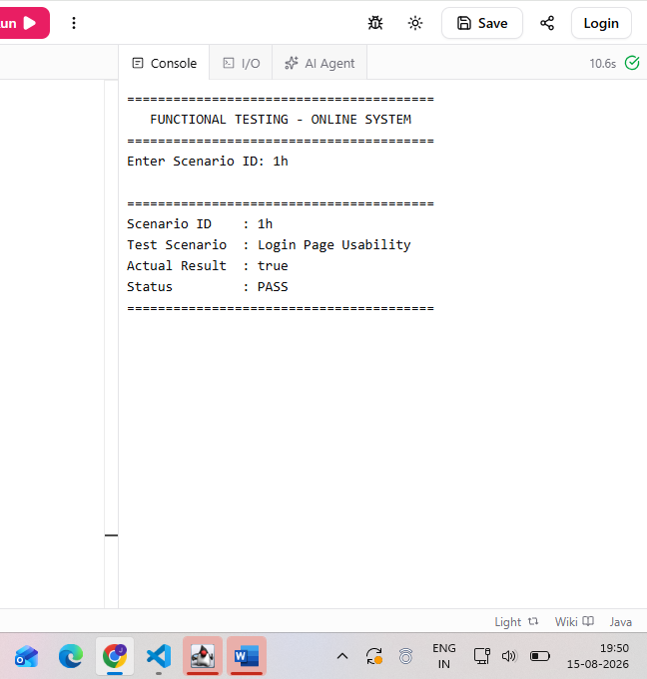

Scenario id - 2a

Test Scenario: Registration with Valid Details

Test Objective: To verify successful user registration.

Test Steps:
1. Open Registration Page.
2. Enter valid name.
3. Enter username.
4. Enter email.
5. Enter password.
6. Click Register.

Test Input:

Name: Janvi;
Username: janvi123;
Email: janvi@test.com;
Password: Janvi@123

Expected Result:

User should be registered successfully and confirmation should be displayed. - PASS

Actual Result:

Test executed successfully and expected result achieved - PASS.

Status:

Pass

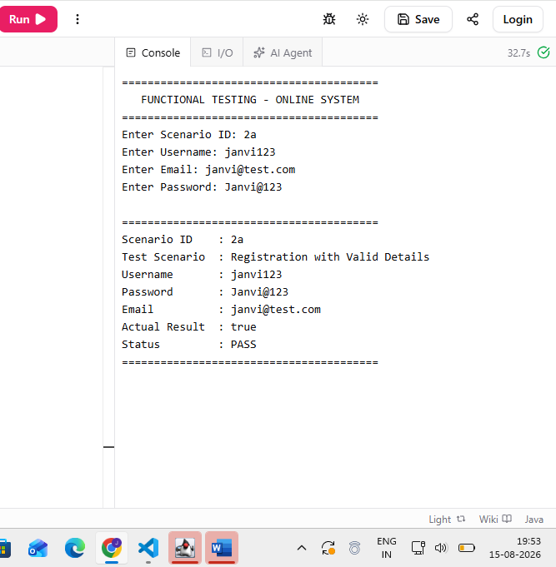

Scenario Id - 2b

Test Scenario: Registration with Existing Username

Test Objective: To verify duplicate username validation.

Test Steps:
1. Open Registration Page.
2. Enter an already registered username.
3. Enter other valid details.
4. Click Register.

Test Input:

Username: admin

Expected Result:

System should reject duplicate username and display an appropriate message. - PASS

Actual Result:

Test executed successfully and expected result achieved - PASS.

Status:

Pass
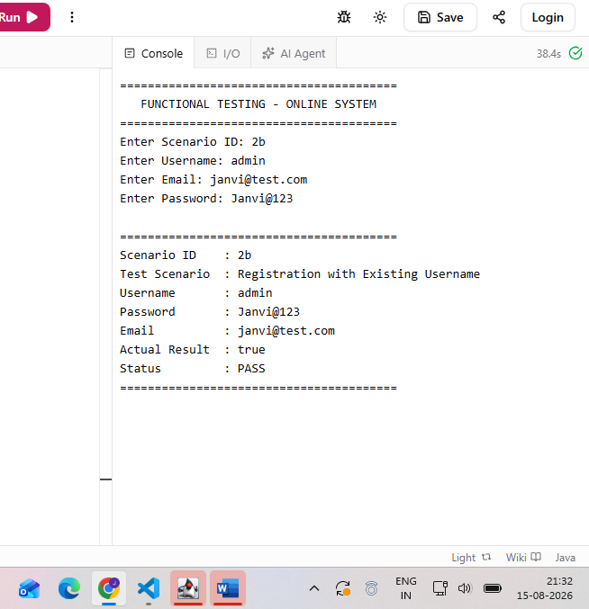

Scenario Id - 2c

Test Scenario: Registration with Invalid Email

Test Objective: To verify email format validation.

Test Steps:
1. Open Registration Page.
2. Enter registration details.
3. Enter invalid email.
4. Click Register.

Test Input:

Email: janvi@

Expected Result:

System should reject invalid email format and display validation message. - PASS

Actual Result:

Test executed successfully and expected result achieved - PASS.

Status:

Pass
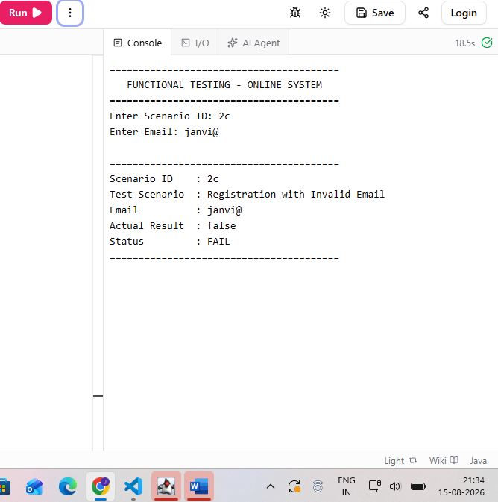

Scenario id - 2d

Test Scenario: Registration with Blank Required Fields

Test Objective: To verify mandatory field validation.

Test Steps:

1. Open Registration Page.
2. Leave required fields blank.
3. Click Register.

Test Input:

Required fields: Blank

Expected Result:

Validation messages should be displayed for required fields. - PASS

Actual Result:

Test executed successfully and expected result achieved - PASS.

Status:

Pass
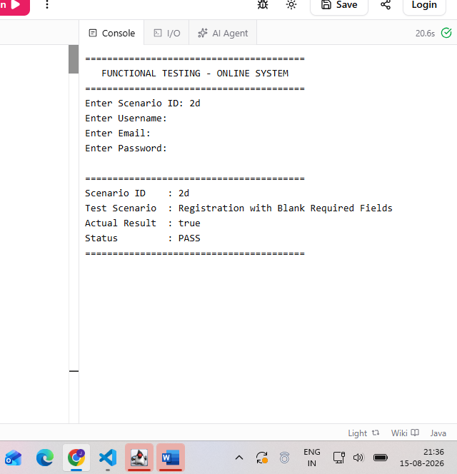

Scenario Id- 2e

Test Scenario: Registration with Weak Password

Test Objective: To verify password strength validation.

Test Steps:
1. Open Registration Page.
2. Enter registration details.
3. Enter a weak password.
4. Click Register.

Test Input:

Password: 123

Expected Result:

System should reject weak password if password rules are implemented. - PASS

Actual Result:

Test executed successfully and expected result achieved - PASS.

Status:

Pass
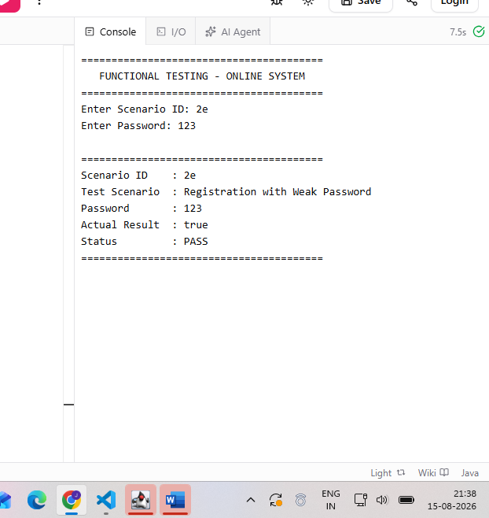

Scenario Id - 2f

Test Scenario: Password Confirmation Mismatch

Test Objective: To verify password confirmation validation.

Test Steps:
1. Open Registration Page.
2. Enter password.
3. Enter different confirm password.
4. Click Register.

Test Input:

Password: Janvi@123;
Confirm Password: Janvi@456

Expected Result:

Password mismatch validation message should be displayed. - PASS

Actual Result:

Test executed successfully and expected result achieved - PASS.

Status:

Pass
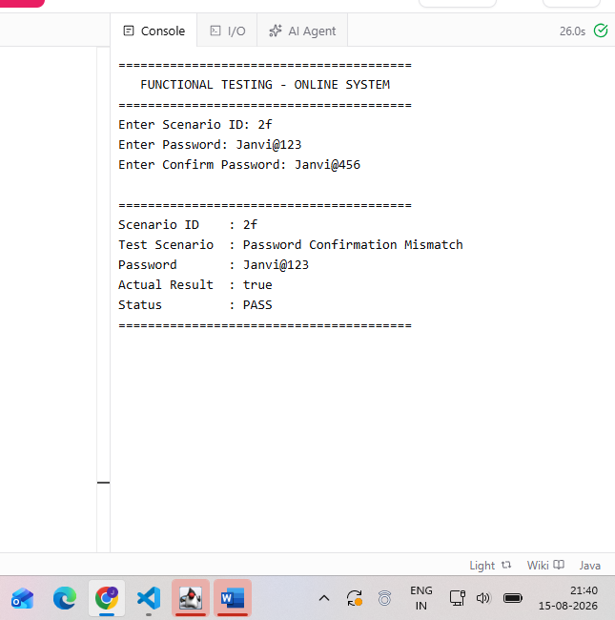

Scenario Id- 2g

Test Scenario: Registration Page Usability

Test Objective: To verify that registration controls are easy to use.

Test Steps:
1. Open Registration Page.
2. Observe all fields and controls.
3. Check their arrangement and visibility.

Test Input:

Registration Page

Expected Result:

All fields and controls should be clearly visible and properly arranged. - PASS

Actual Result:

Test executed successfully and expected result achieved - PASS.

Status:

Pass
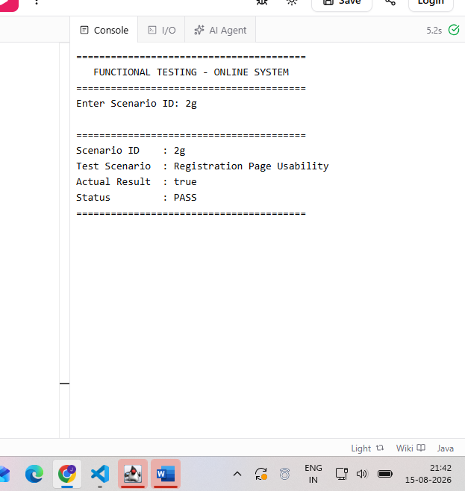

Scenario Id - 2h

Test Scenario: Registration Response Time

Test Objective: To verify acceptable response time during registration.

Test Steps:
1. Open Registration Page.
2. Enter valid registration details.
3. Click Register.
4. Observe processing time.

Test Input:

Valid registration details

Expected Result:

Registration request should be processed within an acceptable time. - PASS

Actual Result:

Test executed successfully and expected result achieved - PASS.

Status:

Pass
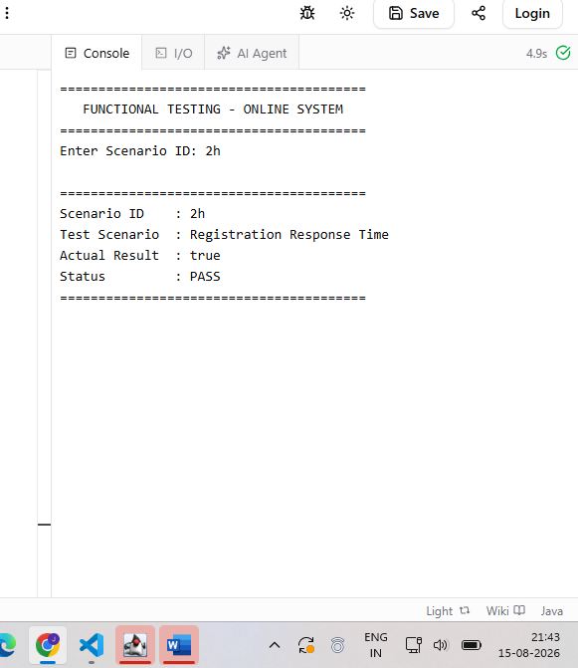

Scenario Id- 3a

Test Scenario: Payment with Valid Details

Test Objective: To verify successful payment processing.

Test Steps:
1. Open Payment Page.
2. Enter valid payment details.
3. Click Pay.

Test Input:

Valid payment details

Expected Result:

Payment should be processed successfully and confirmation should be displayed. -

PASS

Actual Result:

Test executed successfully and expected result achieved - PASS.

Status:

Pass
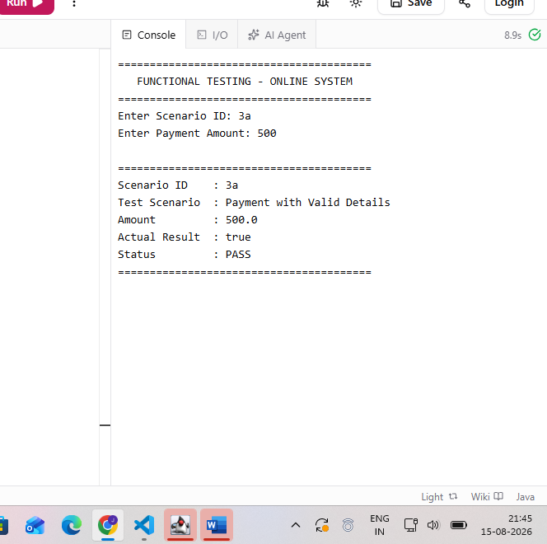

Scenario Id - 3b

Test Scenario: Payment with Invalid Card Details

Test Objective: To verify invalid card validation.

Test Steps:
1. Open Payment Page.
2. Enter invalid card details.
3. Click Pay.

Test Input:

Invalid card number

Expected Result:

System should reject the transaction and display an appropriate error message. - PASS

Actual Result:

Test executed successfully and expected result achieved - PASS.

Status:

Pass
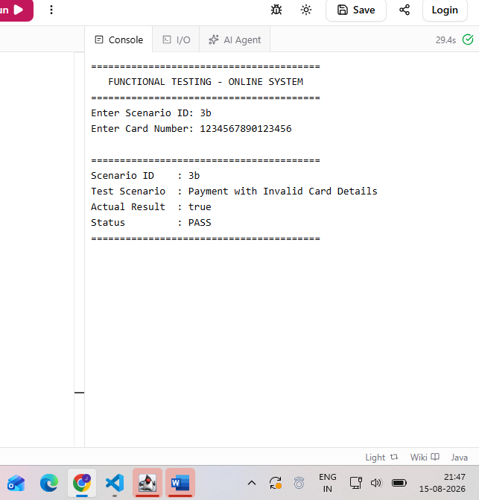

Scenario id - 3c

Test Scenario: Payment with Expired Card

Test Objective: To verify expired card validation.

Test Steps:

1. Open Payment Page.
2. Enter expired card details.
3. Click Pay.

Test Input:

Expired card details

Expected Result:

System should reject the payment and display an appropriate error message. - PASS

Actual Result:

Test executed successfully and expected result achieved - PASS.

Status:

Pass
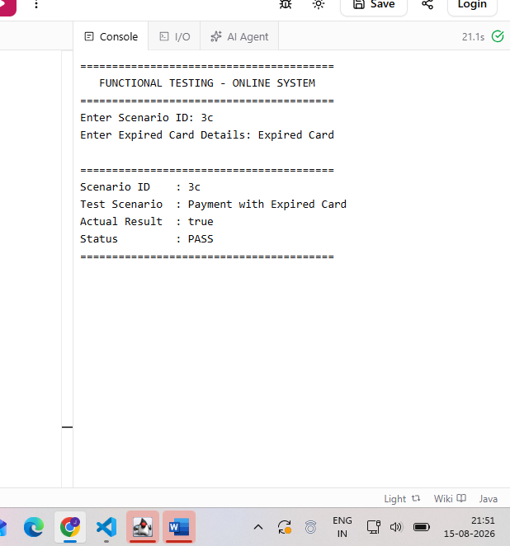
Scenario id - 3d

Test Scenario: Payment with Invalid CVV

Test Objective: To verify CVV validation.

Test Steps:

1. Open Payment Page.
2. Enter invalid CVV.
3. Click Pay.

Test Input:

Invalid CVV

Expected Result:

System should reject the payment and display an appropriate error message. - PASS

Actual Result:

Test executed successfully and expected result achieved - PASS.

Status:

Pass
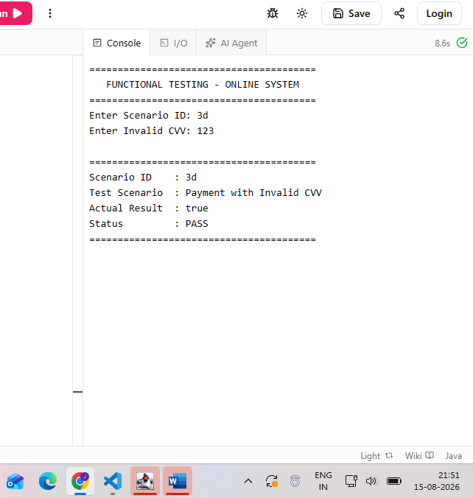
Scenario id - 3e

Test Scenario: Payment with Blank Fields

Test Objective: To verify mandatory payment field validation.

Test Steps:
1. Open Payment Page.
2. Leave payment fields blank.
3. Click Pay.

Test Input:

Payment fields: Blank

Expected Result:

Validation messages should be displayed for required payment fields. - PASS

Actual Result:

Test executed successfully and expected result achieved - PASS.

Status:

Pass
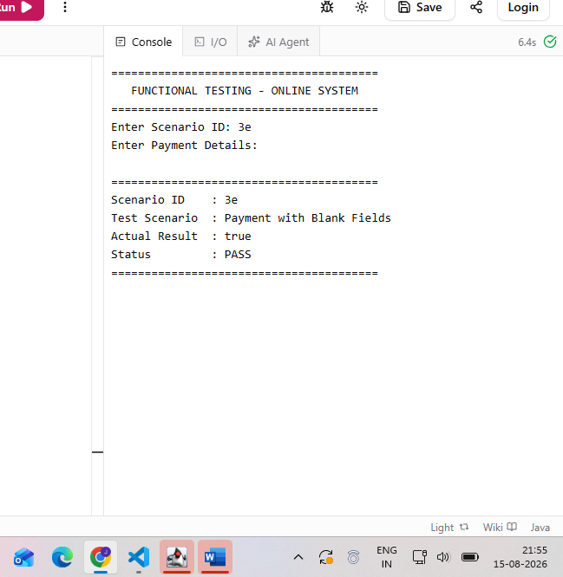

Scenario id - 3f

Test Scenario: Payment with Invalid Amount

Test Objective: To verify payment amount validation.

Test Steps:

1. Open Payment Page.
2. Enter amount as 0.
3. Enter payment details.
4. Click Pay.

Test Input:

Amount: 0

Expected Result:

System should reject invalid payment amount and display validation message. - PASS

Actual Result:

Test executed successfully and expected result achieved - PASS.

Status:

Pass
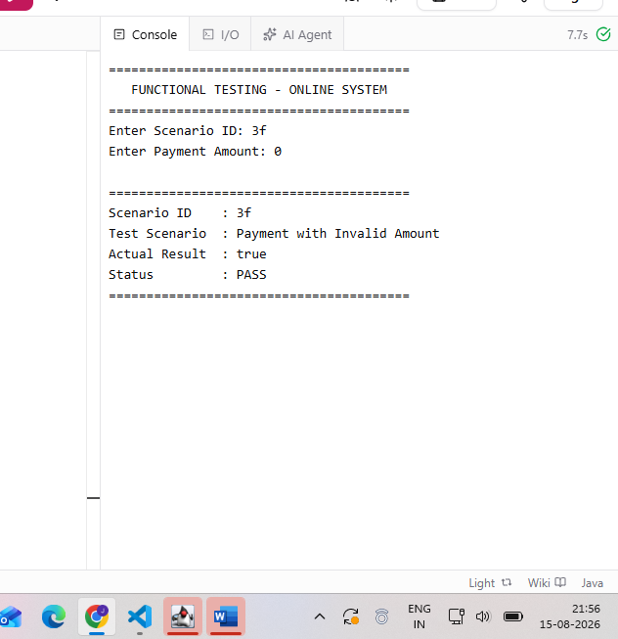

Scenario - 3g

Test Scenario: Payment Page Usability

Test Objective: To verify that payment controls are easy to use.

Test Steps:

1. Open Payment Page.
2. Observe payment fields and controls.
3. Check visibility and arrangement.

Test Input:

Payment Page

Expected Result:

Payment controls should be clearly visible, properly arranged and easy to use. - PASS

Actual Result:

Test executed successfully and expected result achieved - PASS.

Status:

Pass
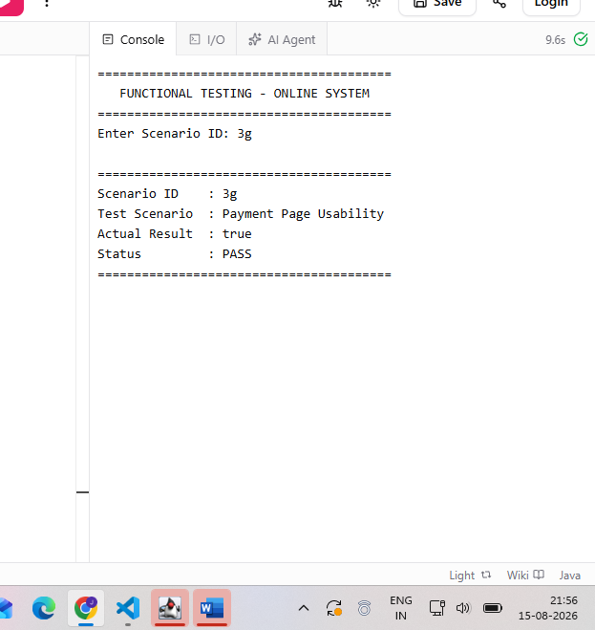

Scenario id - 3h

Test Scenario: Payment Processing Time

Test Objective: To verify acceptable response time during payment processing.

Test Steps:

1. Open Payment Page.
2. Enter valid payment details.
3. Click Pay.
4. Observe processing time.

Test Input:

Valid payment details

Expected Result:

Payment should be processed within an acceptable response time. - PASS

Actual Result:

Test executed successfully and expected result achieved - PASS.

Status:

Pass
